**“Water Management And Sustainable Agriculture”**

Submitted in 49TH Jawaharlal Nehru National Science, Mathematics and

Environment Exhibition for Children — 2022

**JAWAHAR NAVODAYA VIDYALAYA, SARANG DIST. DHENKANAL**



**Submitted by: Guided by:**

Ma.Kaibalya K. Behera Muna Mohapatra

Class : XI Science TGT(SC), JNV Sarang

Dist. Dhenkanal

**Abstract**

Do you or your family have a lawn, garden, or potted plants that you water regularly? Irrigation—or the artificial application of water to plants and landscaping—accounts for over two-thirds of the world's freshwater consumption (U.S. Geological Survey, 2016)! While that total includes farms, in the United States landscape irrigation still accounts for almost one-third of residential water use. As much as half of that water is wasted due to inefficient watering methods (WaterSense, 2016) like watering when the soil is already wet.

The project Green Technology: Build an Electronic Soil Moisture Sensor to Conserve Water shows you how to build a soil moisture sensing circuit. The circuit has two probes that you insert into soil (Figure 1) and a small LED that turns on when the soil is dry. If the LED is off, that means the soil is already wet. This allows you to use the circuit as an indicator for when you need to run a sprinkler system, water a garden, or water indoor potted plants.

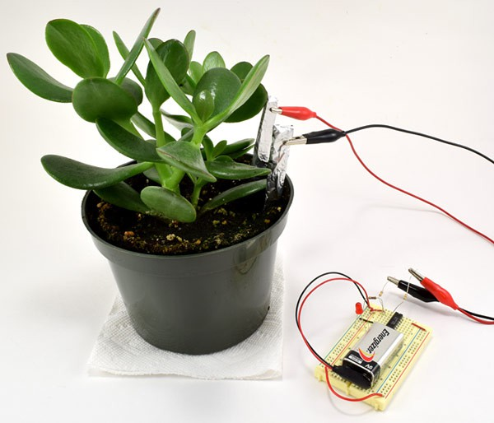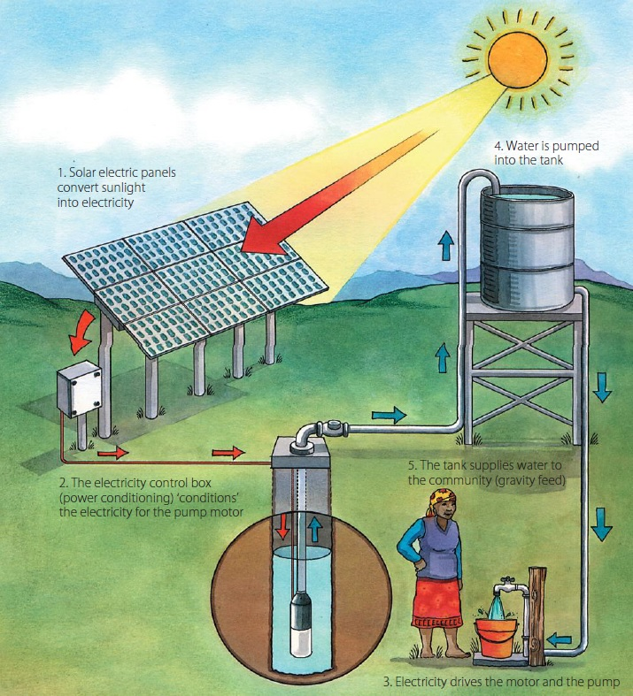

**Introduction**

India is a developing nation with a very large population. Due to increasing population, the basic need such as food and water is increasing day by day. Thus there is a need of saving these resources and utilize them in an efficient manner. Since water is one of the most important elements in our daily life, thus we must use efficient ways to utilize water and save it for future generations. One of method is efficient irrigation management practices for fields. Irrigation water management practices could greatly benefit by the knowledge of moisture in the soil. To determine the soil moisture we have designed and developed a nickel probes based soil moisture sensor and a response monitoring system. By knowing the moisture value, we can estimate when to water and how much to water the fields so that there is no over-watering or wilting of crops. These practices will increase crop yield, improve quality of crops, conserve water resources, save energy, and decrease fertilizer supplies.

How Soil Moisture Sensor works?

The working of the soil moisture sensor is pretty straightforward.

The fork-shaped probe with two exposed conductors, acts as a variable resistor (just like a potentiometer) whose resistance varies according to the water content in the soil.



This resistance is inversely proportional to the soil moisture:

* The more water in the soil means better conductivity and will result in a lower resistance.
* The less water in the soil means poor conductivity and will result in a higher resistance.
* The sensor produces an output voltage according to the resistance, which by measuring we can determine the moisture level

Procedure

1. Go to a garden center and decide what type of plant you want to use for your experiment. Talk to an employee to find out what conditions the plants require to grow: type of soil, amount of sunlight, and especially how much and how often they should be watered.
2. Build the soil moisture sensor and test it on several of that type of plant. The LED should turn off when you insert the probes into damp or wet soil. Depending on the type of plants and soil you use, you may need to adjust the default circuit so the LED comes on at an appropriate soil moisture level.

* There are several ways to adjust the circuit. See the Variations section of the original project for some ideas.
* Also keep in mind that you only have one circuit, but will be monitoring multiple plants. It is important that you are able to easily remove and re-insert the soil probes at a fixed distance and depth, which is part of the engineering challenge of the original project. You could also leave a set of probes in each pot and use alligator clips to disconnect and reconnect them from the circuit.

3. Separate your plants into at least two groups (make sure you have at least three plants in each group). Water one group with a specific amount of water according to a regular schedule (for example, every day or twice per week). Water one group with the same specific amount of water each time, but only according to the sensor (only when the LED turns on). You could also add other groups; for example, an over-watered group (always add enough water to keep the soil saturated) or an under-watered group (wait to apply water a few days after the LED comes on).

4. Water the groups of plants according to the schedules you defined. Keep track of the total water consumption for each plant, plant growth, and plant health. Does using the soil moisture sensor allow you to conserve water while maintaining or increasing plant health and growth?

# Benefits and Practical Uses Of Moisture Sensor:-

# Agriculture

Irrigation of crops represents 90% of the water used worldwide. Monitoring soil moisture in the root zone of crops will optimize irrigation. The benefits of optimizing irrigation scheduling with soil moisture sensors includes increasing crop yields, saving water, protecting local water resources from runoff, saving on energy costs, saving on fertilizer costs and increasing the farmer profitability.

# Archeology

In arid parts of the world, ancient people farmed and irrigated crops to feed themselves and their livestock. In the desert southwestern US, Mesoamericans were able to grow crops in seemly waterless desert environments, and the irrigation practices of these ancient people remain a mystery. It is believed by some archeologists that the ancient Mesoamericans extracted water from clay confining layers for their crops. Soil moisture probes such as the HydraProbe are deployed in archeological sites to better understand the soil hydrology and to help us understand the day-to-day lives of our distant ancestors.

# Biofuel Studies

For thousands of years, people have been growing corn and other crops to sustain the nutritional requirements of the population and livestock. Over the centuries, crops have been domesticated and changed genetically from their wild counterparts for this specific purpose. Now that biofuels are a possible alternative energy source, crops need to be cultivated in order to produce ethanol. In recent years, a new branch of agronomy emerged called biomass studies. Agronomists that specialize in biomass look at new ways to ferment crops to increase the ethanol yields. The goal is to be able to produce ethanol from not only the fermentation of the fruit, but the stems, leaves, and roots. Soil moisture sensors are used in this research to characterize the hydrological requirements of the biomass crops.

# Erosion Studies

Each year, erosion from changes in land use causes millions of dollars in damage to property and natural water systems. In order to understand the causes of erosion and make predictions about when and where erosion occurs, hydrologists need to record rain fall, sediment and soil moisture. The water infiltration rate of soil is a function of soil moisture. If the soil is dry, the infiltration rate will be sufficient to prevent run off. Overland water flow may occur if rain events happen at a time when soil is saturated. Monitoring soil moisture is an important input parameter into erosion prediction models.

# Drought Forecasting Models

Regional drought can severely affect the economy and even lead to starvation in some areas of the world. With advances in computer processing and environmental modeling methods, scientists are beginning to understand regional water budgets and hydrological processes. An important input into drought forecasting models is changes in regional soil moisture. Long-term soil moisture data over large regions can be used to predict and characterize harmful droughts.

# Dust Control

Poor air quality from particulates in air can have negative consequences to not only human health but regional ecosystems. Vehicular traffic on unpaved roads can lead to major dust problems. In areas of the Southwestern US, the soil is naturally abundant in several types of asbestos. Local officials close unpaved roads based on soil moisture conditions to prevent dangerous dust situations.

# Landslide Studies

Changes in land use may increase the likelihood of landslides dangers. Each year, millions of dollars in damage to property and lives are lost due to landslides. Predicting and preventing landslide hazards is becoming very important in some urban areas. The inputs to landslide prediction models are slope, vegetation, toe slope, soil cohesiveness, and soil moisture. In some areas that experience perched water tables, the soil in the perched water table becomes very heavy as the soil becomes saturated thus becoming more influenced by gravity. Monitoring soil moisture is an important indicator for landslide hazards.

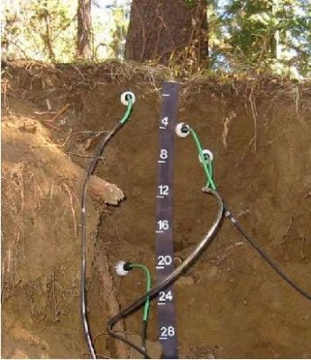

CONCLUSION

The soil moisture response monitoring system designed is very simple to understand and handle. It can be operated by all age-groups of farmer. It can be reprogrammable to add more features. The moisture is measured up to the root zone of the crop. Thus it can be used to check the moisture value for any crop. Sensor can be placed vertically in the soil to check the depth of irrigated water and also it can be placed horizontally at different heights in the soil according to the crop. It is user friendly and can also be used by uneducated farmers. The moisture is checked in the morning and the evening and it is found that moisture is linear up to 20%VWC (volumetric water content) and afterwards output voltage becomes almost constant. Monitoring soil moisture will not only benefit environmental researchers but farmers, golf course superintendents, archeologists, and regulators. Soil moisture sensors play an important role in helping to protect water resources and understand our ever changing climate.